Nate Riggs
CS-330
Southern New Hampshire University
1/17/2025
Milestone 1
The 2D scene that I have chosen to replicate in 3D is the following image of a serene Japanese garden with a wooden house, a stone lantern, rocks, neatly arranged moss, and gravel paths. It contains multiple objects with distinct shapes, textures, and arrangements.
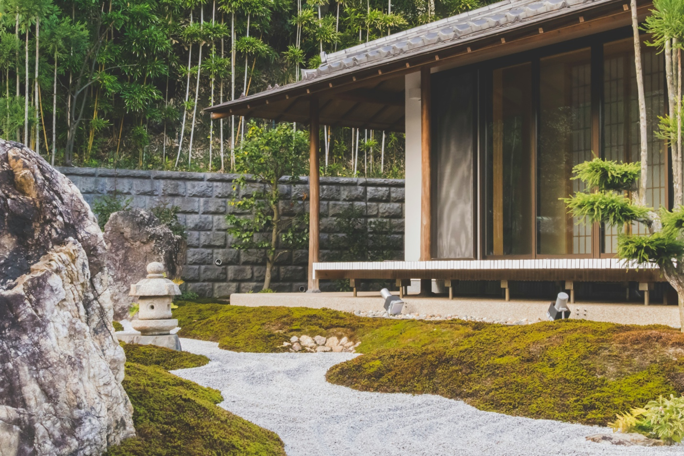
The objects that I will be replicating in the scene are but are not limited to, the stone lantern, the large rock, the wooden house with pillars and a roof, and the gravel path and the moss and grass that would make up a ground plane. These items were chosen because they represent the core elements of the garden and each offers unique opportunities for exploring textures, shapes, and structural complexity. Each object can be broken down into basic 3D shapes as follows:
- Stone Lantern
  - A cylinder can be used for the main body and the top roof of the lantern
  - A sphere can be used to replicate some decorative elements of the lantern
  - A box can be used for the lantern’s base platform
- Large Rock
  - A deformed sphere can be used to model the organic, irregular shape of the rock
- Wooden House
  - A box can be used for the house’s main structure
  - A prism can be used for the roof’s slanted design
  - A cylinder can be used for the vertical pillars supporting the roof
- Gravel Path and Moss
  - A plane can be used as the ground surface for the entire scene
  - A torus or spheres can be used for small decorative gravel details or moss clumps. Colors and textures can also be used to achieve the desired look for the scene,

Reference List
Nero, P. (n.d.). wooden-house-with-glass-sliding-door-beside-trees-at-daytime. Unsplash. https://unsplash.com/@pepe_nero?utm_content=creditCopyText&utm_medium=referral&utm_source=unsplash">pepe nero on Unsplash

